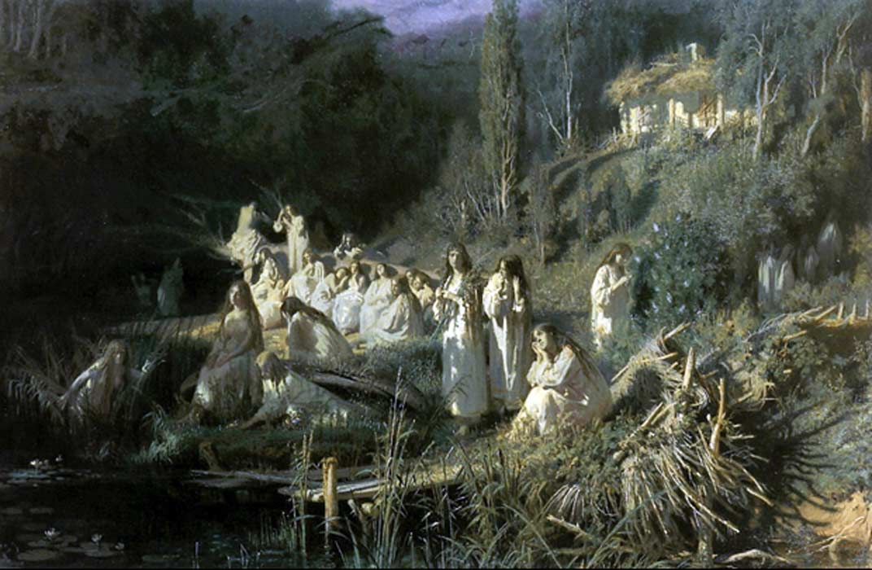
30 SEPTEMBER, 2016 - 00:49 KERRY SULLIVAN

Rusalka: The Mythical Slavic Mermaid
- READ LATER

PRINT
In Slavic mythology, a rusalka (plural: rusalki) is something akin to the Celtic mermaids or the Greek sirens. In short, rusalki are beautiful young women who dwell in bodies of water and enjoy enticing men. The concept of rusalki originated from a Slavic pagan tradition where the young women were symbols of fertility. These nymphs did not interfere too much with human life and mainly served to provide life-giving moisture to the fields and forests every spring when they came ashore to dance in the spring moonlight. The water spirits were believed to help crops grow plentifully and so were generally treated with respect. In the modern era, a large mythos mostly unrelated to fertility has sprung up around the beguiling young women of the water. By the 19th century, the main objective of a rusalka had transformed into harassing the human population.

Origins of Rusalki
While the pagan water nymph occurred naturally, the mermaid rusalka has quite varied origin stories. Typically, they involved young women dying violent deaths. Sometimes it is murder, sometimes it is a suicide, but usually it is a death by drowning. Stories of rusalka often revolve around women betrayed by a husband or lover. Some rusalki are young women who jumped into a lake or river because she was pregnant out of wedlock. Other origin stories say a rusalka is any young woman who dies a virgin, regardless of whether the death was violent or natural. Still other myths say that babies who die before being baptized are reborn as water sprites. This version ties in with the idea that babies born out of wedlock were supposedly drowned. Finally, some myths claim that a rusalka is any unclean soul, in other words, anyone who killed himself or herself by jumping into the lake or river.
- Magical Mermaids of Japanese Folklore
- Are tales of mythical mermaids inspired by a real-life medical condition?
- When the Church Bells Ring: Themes and Proclivities of the Danish Folktale "Agnete and the Merman"
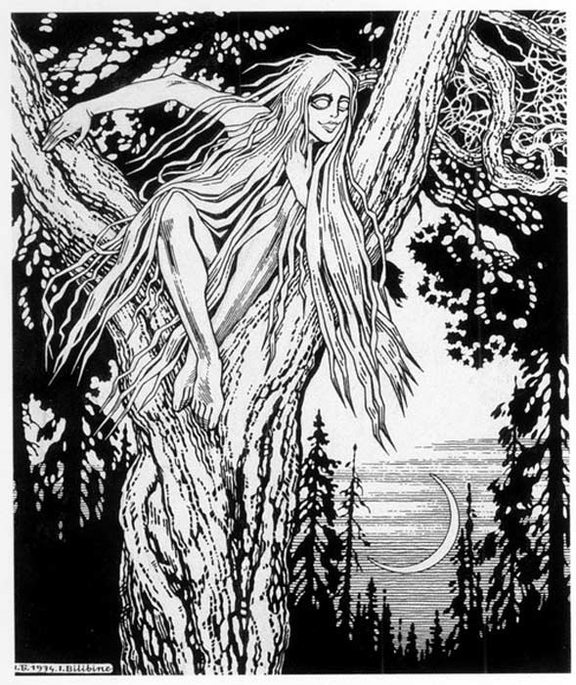
Rusalka by Ivan Bilibin , 1934. ( Public Domain )

Many rusalki were said to have finite lives. These souls linger on in water until their allotted time on earth is complete (this version of events usually accompanies the violent death or suicide origin stories). Others must remain until their death is avenged (this version of events usually accompanies the murder or jilted lover origin stories). Rusalki haunt lakes, rivers, ponds, marshes, swamps, and any other body of water. They are often described as being slim with large breasts. They are pale-skinned and have long, loose hair that is either blonde, light brown, or green. Their eyes are said to not contain pupils and, if the rusalka is wicked, can be blazing green. Invariably, the women wear light, sheer robes as though made of mist. Rusalki are representations of universal beauty and even the wicked ones are greatly admired and feared in Slavic society.
The motivations of a rusalka vary depending on where she is living, a fact that may have its roots in the ancient pagan myths. For in places where plant life is bountiful and crops grow well, such as in Ukraine and areas around the Danube River, the rusalki are charming and playful. However, in harsher climes, the rusalki are wild and wicked. These malevolent spirits would crawl out from the water in the middle of the night in order to ambush humans, especially men, who they would then drag, alive, back into the watery depths.
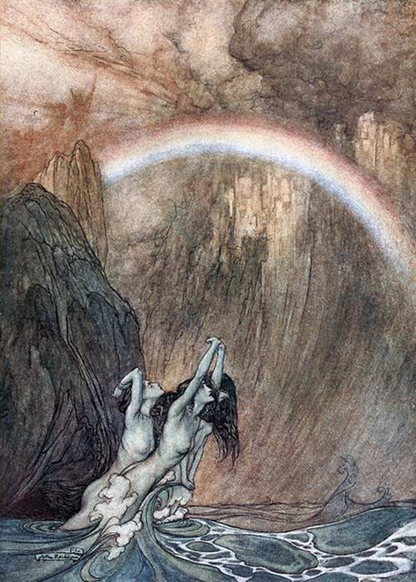
Mermaid coming out of the water. ( Public Domain )
- Legends of the Selkies, Hidden Gems of Sea Mythology
- Oshun, African Goddess of Love and Sweet Waters
- Tracing the origins of the Serpent Cult

Rusalki Week
Unlike fishtailed mermaids, Rusalki have legs and can walk on land. They enjoy dancing and climbing in trees. Every year at the beginning of summer, around the first week of June, Slavic cultures celebrate Rusalki Week. During this time, swimming in any body of water is absolutely forbidden, as it will mean certain death. The rusalki are believed to come ashore to play in the weeping willow and swing in birch trees, then they gather together to perform circle dances under the moonlight. Any passerby who should have the misfortune of witnessing one of these events is forced to dance with them until he dies. At the end of the week, towns and villages near bodies of water hold ceremonial burials in order to appease the rusalki and/or banish them back into the water. These traditions were maintained well into the 1930s until they were stamped out by Soviet forces.
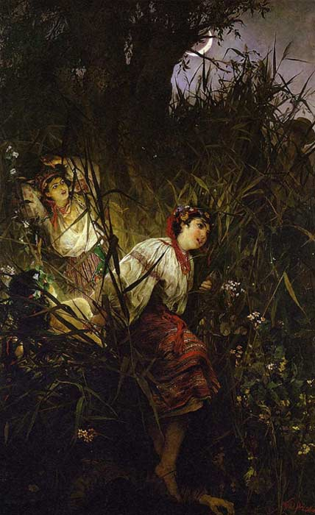
Rusałki by Witold Pruszkowski . ( Public Domain )

Rusalka Poem
The Rusalki feature in many Russian and Slavic artworks including paintings, operas, and novels. One of the most renowned homages to a rusalka was written by poet Alexander Pushkin. The poem, published posthumously and entitled Rusalka by his estate, gives a good depiction of how rusalki are imagined in Slavic cultures.
In lakeside leafy groves a friar
Escaped the world; out there he passed
His summer days in constant prayer,
Deep studies and eternal fast.
Already with a humble shovel
The elder dug himself a grave,
And calling saints to bless his hovel,
Death—nothing other—did he crave.
So once upon a falling night he
Bowed down beside his drooping shack
And meekly prayed to the Almighty.
The grove was turning slowly black;
Above the lake the mist was lifting;
Through milky clouds across the sky
A ruddy moon was softly drifting,
When water drew the friar’s eye –
He looks; his heart is full of trouble,
Of fear he cannot quite explain;
He sees the waves rise more than double
And suddenly grow calm again.
Then, white as first snow of the highlands,
Light-footed as nocturnal shade,
There comes ashore and sits in silence
Upon the bank a naked maid.
She looks at him and brushes gently
The hair and water off her arms.
He shakes with fear and looks intently
At her seductive, luscious charms.
With eager hand she waves and beckons,
Nods quickly, smiling from afar,
And shoots within two flashing seconds
Into still water like a star.
The glum old man slept not an instant
All night. All day not once he prayed;
Before his eyes still hung and glistened
The wondrous girl’s persistent shade.
The grove puts on the gown of nightfall;
The moon walks on the cloudy floor;
And there’s the maiden—young, delightful,
Reclining on the spellbound shore.
She looks at him, her hair she brushes,
Smiles, sends him kisses sweet and wild,
Plays with the waves—caresses, splashes –
Now laughs, now whimpers like a child,
Moans tenderly, calls louder, louder…
“Here, monk, here, monk! To me, to me!”
Then vanishes in limpid water,
And all is silent instantly…
On the third day the ardent hermit
Was sitting on the shore, in love,
Awaiting the voluptuous mermaid,
As shade was lying on the grove.
Night ceded to the sun’s emergence;
By then the monk had disappeared.
It’s said a crowd of local urchins
Saw floating there a wet gray beard.
Top image: Ivan Kramskoi, The Mermaids, 1871. Source: Public Domain
By Kerry Sullivan

Sources:
Alice. "Slavic Mythology I: Water Spirits, Demons, and Creatures." Nøkk & Myling's Classification of Supernatural & Preternatural/ Mythological Beings. Nøkk & Myling, 06 Dec. 2011. Web. 24 Sept. 2016. http://nokkandmyling.blogspot.com/2011/06/slavic-mythology-i-water-spirits-and.html
The Editors of Encyclopædia Britannica. "Rusalka." Encyclopedia Britannica Online. Encyclopedia Britannica, 2016. Web. 24 Sept. 2016. https://www.britannica.com/topic/rusalka
Meet the Slavs. "Rusalka: Slavic Mermaid." Meet the Slavs. Meet the Slavs, 1 Apr. 2014. Web. 24 Sept. 2016. http://meettheslavs.com/rusalka-slavic-mermaid/

